Street Lightning Final Documentation

2023

Contents

1. Introduction 2

2. Procedure 2

3. Retrospective 3

4. Reference 3

## Introduction

The project aims to develop and implement a sophisticated and advanced system specifically designed to detect and identify faulty street lights in a given area. This system accurately and efficiently identifies malfunctioning lights and stores their data on an SD Card. This will help to ensure that the streets are well-lit and safe for all users and that any issues can be quickly and effectively addressed in a timely manner.

# Procedure

The execution line for this small IOT project was a little chaotic because the general idea of how to store the data changed every week, we didn’t have an SD card reader in the beginning, and we thought to share the data over MQTT and then save the data into a “.csv” file, but over time we were given the opportunity to use the card reader, so we immediately changed the project in that direction.

Initially, we had two separated code programs one was able to get the current location of the module and the other was the basic light sensor. These programs were merged into one piece of code and uploaded into the ESP32.

The system works in a way that it gets the location and lights value, writing the values into the SD Card through the SD Card. Then the SD Card is transferred a machine that supports the Node-Red with a world map. The data is getting displayed with accurate world positioning(log, lat).

In the screenshot below can be seen diagram of the structure of the project:

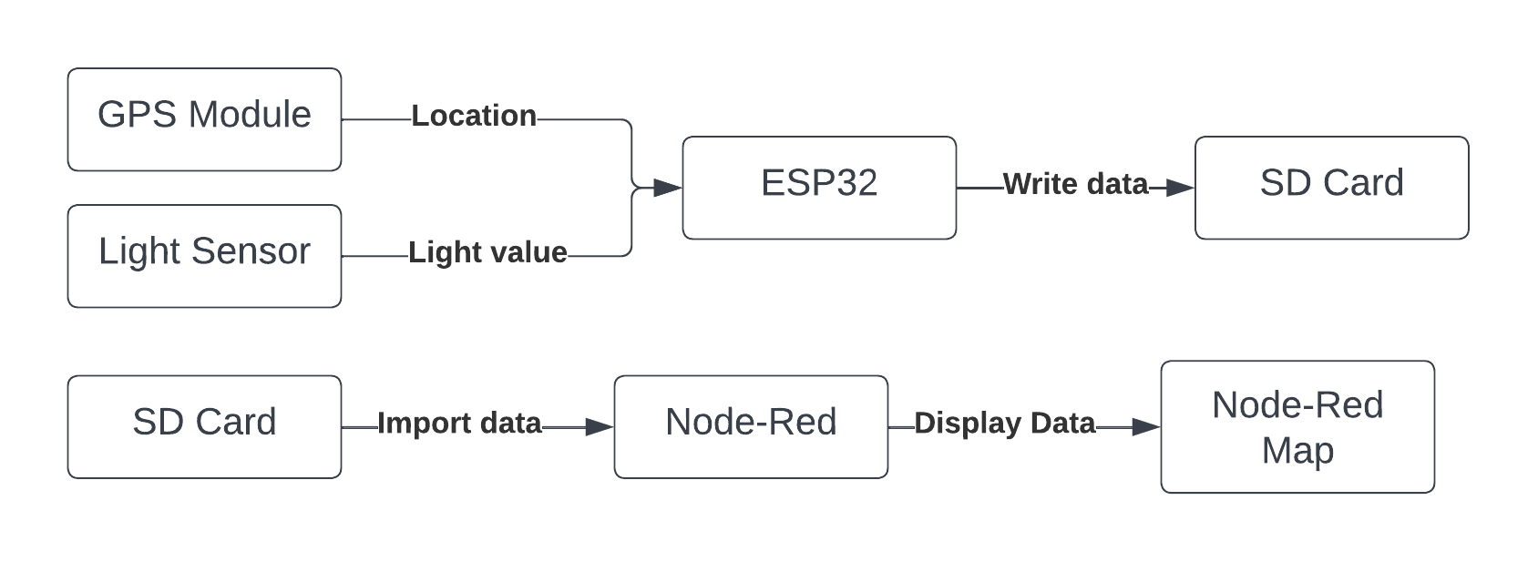

## Retrospective

The Street Lights Detection project was a great learning experience for all members. We were able to work together effectively and achieve our goals. The project was challenging, but we were able to overcome any obstacles that came our way.

One of the strengths of our group was our diversity of skills and perspectives. We were able to bring different ideas to the table and work collaboratively to find solutions. Our communication was strong and regular, which helped us stay on track and meet deadlines.

Overall, we are proud of the work we accomplished and we look forward to applying what we learned to future projects.

## 4. Reference

1. <https://www.instructables.com/ESP32-Micro-SD-Card-Interface/>

2. <https://www.youtube.com/watch?time_continue=1&v=fPvW-dtB6i0&embeds_euri=https%3A%2F%2Fwww.google.com%2Fsearch%3Fq%3Dsd%2Bcard%2Breader%2Besp32%26source%3Dlmns%26tbm%3Dvid%26bih%3D961%26biw%3D1920%26rlz%3D1C1GCEA_enBG873BG873%26hl%3Dbg%26sa%3DX%26ve&source_ve_path=Mjg2NjY&feature=emb_logo&ab_channel=ElectronicClinic>

3. https://www.youtube.com/watch?v=wYmISJG3KfI&t=1s&ab_channel=pcbreflux